Item | Needed ✔ | Present ✔  WeDo Reset Form | Item | Needed ✔ | Present ✔ | Item | Needed ✔ | Present ✔
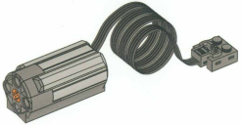  Power Functions M-Motor | 1 |  | 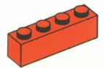  Brick 1 x 4 (Red) | 2 |  | 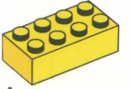  Brick 2 x 4 (Yellow) | 2
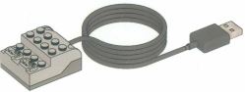  USB Hub | 1 |  | 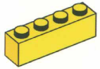  Brick 1 x 4 (Yellow) | 2 |  | 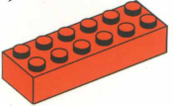  Brick 2 x 6 (Red) | 2
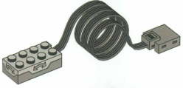  Tilt Sensor | 1 |  | 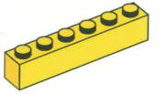  Brick 1 x 6 (Yellow) | 2 |  | 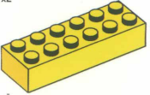  Brick 2 x 6 (Yellow) | 2
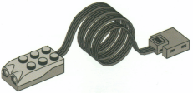  Motion (Distance) Sensor | 1 |  | 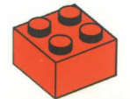  Brick 2 x 2 (Red) | 2 |  | 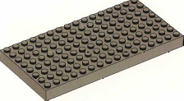  Brick 8 x 16 (Dark Grey) | 1
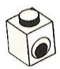  Brick 1 x 1 with Eye Simple Black and White Pattern | 4 |  | 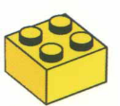  Brick 2 x 2 (Yellow) | 2 |  | 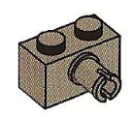  Brick Specialty 1 x 2 with Pin (Dark Grey) | 4
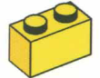  Brick 1 x 2 (Yellow) | 2 |  | 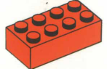  Brick 2 x 4 (Red) | 2 |  | 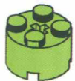  Brick, Round 2 x 2 (Lime) | 4
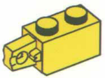  Hinge Brick 1 x 2 Locking with 1 Finger Vertical End (Yellow) | 2 |  | 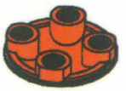  Plate, Round 2 x 2 with Rounded Bottom (Boat Stud) (Red) | 2 |  | 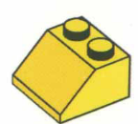  Slope 45 2 x 2 (Yellow) | 2
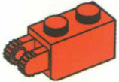  Hinge Brick 1 x 2 Locking with 2 Fingers on End, Vertical (Red) | 2 |  | 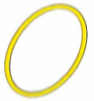  Rubber Belt (Yellow – can be Blue) | 2 |  | 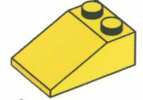  Slope 33 3 x 2 (Yellow) | 2
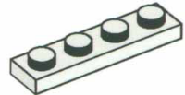  Plate 1 X 4 (White) | 4 |  | 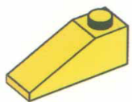  Slope 33 3 x 1 (Yellow) | 2 |  | 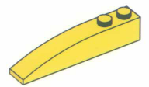  Slope, Curved 6 x 1 (Yellow) | 2
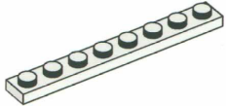  Plate 1 X 8 (White) | 4 |  | 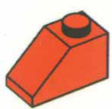  Slope 45 2 x 1 (Red) | 2 |  | 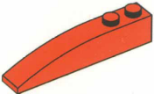  Slope, Curved 6 x 1 (Red) | 2
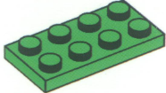  Plate 2 X 4 (Lime) | 4 |  | 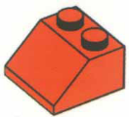  Slope 45 2 x 2 (Red) | 2 |  | 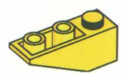  Slope, Inverted 33 3 x 1 (Yellow) | 2
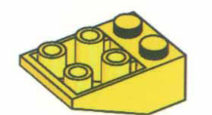  Slope, Inverted 33 3 x 2 with Connections between Studs (Yellow) | 2 |  | 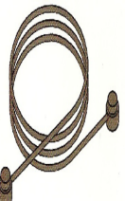  String with End Studs 41L Overall (Black) | 1 |  | 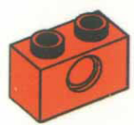  Technic Brick 1 x 2 with Pin Hole (Red) | 6
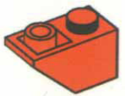  Slope, Inverted 45 2 x 1 (Red) | 2 |  | 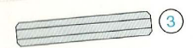  Technic Axle 3 (Light Grey) | 2 |  | 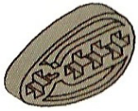  Technic Cam (Dark Grey) | 4
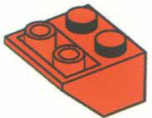  Slope, Inverted 45 2 x 2 (Red) | 2 |  | 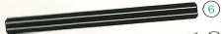  Technic Axle 6 (Black) | 2 |  | 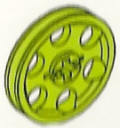  Technic Wedge Belt Wheel (Pulley) (Lime) | 2
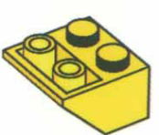  Slope, Inverted 45 2 x 2 (Yellow) | 2 |  | 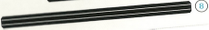  Technic Axle 8 (Black) | 2 |  | 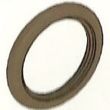  Technic Wedge Belt Wheel Tire (Black) | 2
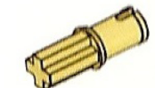  Technic, Axle Pin without Friction Ridges Lengthwise (Tan) | 4 |  | 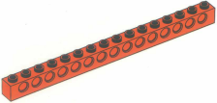  Technic, Brick 1 x 16 with Holes (Red) | 2 |  | 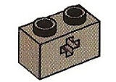  Technic, Brick 1 x 2 with Axle hole (Dark Grey) | 4
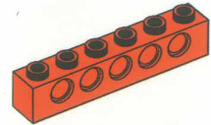  Technic, Brick 1 x 6 with Holes (Red) | 2 |  | 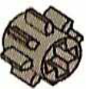  Technic, Gear 8 Tooth (Dark Grey) | 2 |  | 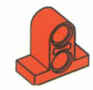  Technic, Pin Connector Plate 1 x 2 x 1 2/3 with Two Holes (Double on Top) (Red) | 2
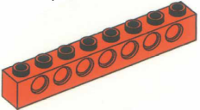  Technic, Brick 1 x 8 with Holes (Red) | 2 |  | 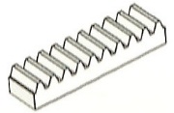  Technic, Gear Rack 1 x 4 (White) | 2 |  | 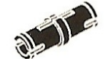  Technic, Pin with Friction Ridges Lengthwise (Black) | 6
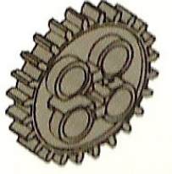  Technic, Gear 24 Tooth with Single Axle Hole (Dark Grey) | 2 |  | 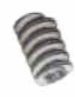  Technic, Gear Worm Screw (Grey) | 1 |  | 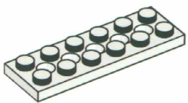  Technic, Plate 2 x 6 with Holes (White) | 4
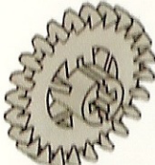  Technic, Gear 24 Tooth Crown with Reinforcements (Grey) | 2 |  | 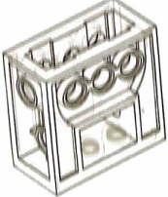  Technic, Gearbox 2 x 4 x 3 1/3 (Clear) | 1 |  | 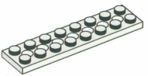  Technic, Plate 2 x 8 with 7 Holes (White) | 4
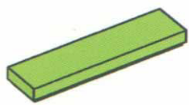  Tile 1 x 4 (Lime) | 2 |  | 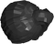  Minifig Cap or Hair | 1 of either
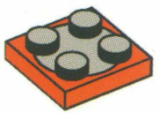  Turntable 2 x 2 Plate (Red and Dark Grey) | 1 |  |   Minifig Torso | 1
Technic Bush (Grey) | 6 |  |   Minifig Head | 1
  Minifig Hips and Legs | 1 |  | 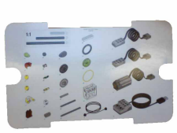  Parts Sheet | 1

Name:

____________________________

Organization:

____________________________

Date:
____________________________

Kit Number:
____________________________

Notes/Comments/Missing Pieces:

